|  |
| --- |
|  |



**26 October 2012** **The Weekly Bulletin of Rotary Club of Kathmandu Mid-Town** **Bc-26.10/012-13**

District : 3292 Web:www.rotarymidtown.org.np Club Id : 26776

**OCTOBER IS VOCATIONAL SERVICE MONTH**

The dimensions of vocational service are limited only by the imagination and ingenuity of clubs and Rotarians. Because Rotarians are classified in their clubs on the basis of their vocations, vocational service is an essential element in the execution of all Rotary programs; its effect is felt throughout the other Avenues of Service.



Friday, 19 October:

Guest speaker, Ms Ms. Pramada Shah, provided an interesting on animal rights operation in future.

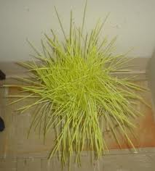 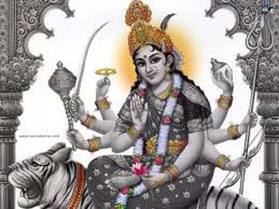 

# Weekly Meetings and Programs :

|  |  |  |
| --- | --- | --- |
| Date | Program/Speaker | Program/Topics of Presentation |
| 26 Oct 2012 | ?? | ?? |
| 2 Nov 2012 | ?? | ?? |
|  |  |  |

    

Friday, 26 October:

**World Sight Day:**

President

pletion

**speaking a few words**

**on the occasion.**

**Releasing Rotaracts’ e-Kaleidoscope, September 2012:**

DG

Mid-Town

during the DG visit to the parent club after the official Club Assembly

on 28 September 2012.

**Changa Chait Champion:**

*It’s the Season to fly Kites*

Flying kites is an integral part of celebrating Dashain. To

revive this fast

0

per person (children free) to

subsidize cost of refreshments including drinks, and

unlimited supply of kites !

The best kite flying champion will be awarded *CHANGA CHAIT CHAMPION.*

**Positive Thinkers Enjoy Better Old Age, finds study:**

Growing old is an

doctors Dennis Charney and Steven Southwick, when coping with extremely stressful life challenges, it is critical to appraise the situation realistically but also to approach it with a positive attitude.''

*……the idea of vocational service. It was the idea that through our work, we can*

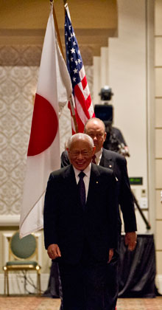

*serve others. We think about others’ needs, and grow to care more for the needs of*

*our communities. We build positive connections between people, and a more*

*peaceful world.*

*This is the idea that has changed my life. It did not change how much I worked, or how hard I worked. But it changed why I worked, and how I experienced my life. It has made me see a higher purpose in everything I do.*

**RI President Sakuji Tanaka**

Happy Vijaya Dashami:

Click here ⇩



**DASHAIN 2069:**

**Dashain is a festival that is celebrated commemorating the victory of good over evil.**

**Dashain is celebrated in memory of a bloody battle between Goddess Durga and demon Mahisasur. As the demon had created troubles for humankind, the goddess fought with him for nine days in her nine different incarnations. But it was on the 10th day, she got victory over the demon. And this 10th day is the day of Vijaya Dashami Tika.**

**Great Quotes:**

***can miss them.***

**Do you know   
  
|**Starting from the day of Ghatasthapana different incarnations of Goddess Shakti are worshipped.

The first day: goddess Shailaputri,

2nd day : goddess Brahmacharini

3rd day : goddess Chandraghanta

4th day : goddess Kushmunda

5th day : goddess Iskandamata,

6th day : goddess Katyani

7th day : goddess Kalaratr

8th day : goddess Mahagauri, and

9th day : goddess Siddhidatr*.*

NB: If you have any information/photo that may be of interest to Rotarians send them to

BC Editor: RR Shrestha email: rryesrr@gmail.com

## 26 Oct 2012 The Weekly Bulletin of Rotary Club of Kathmandu Mid-Town bc-26.10/012-13